Project name: **Design of a Traditional Community School**

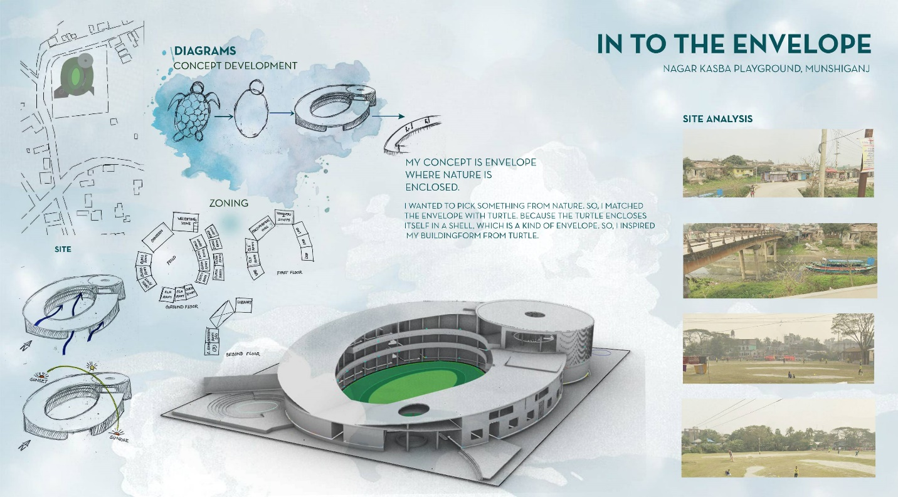

© Shanjida Afrin Eshika | UAP

Student Name: **Shanjida Afrin Eshika**

Year: **2022**

Location: **Nagar Kasba Playground, Munshiganj**

Studio: **Year-2, Semester-2**

Institute: **University of Asia Pacific**

Studio Teachers: **Dr. Nawrose Fatemi & Nabila Ferdousi**

Typology: **School Building**

Height: **36’-0”**

Land Area: **01 acre**

Built Area: **10,000 sqft**

Basement: **None/Surface parking Car: 10 nos.**

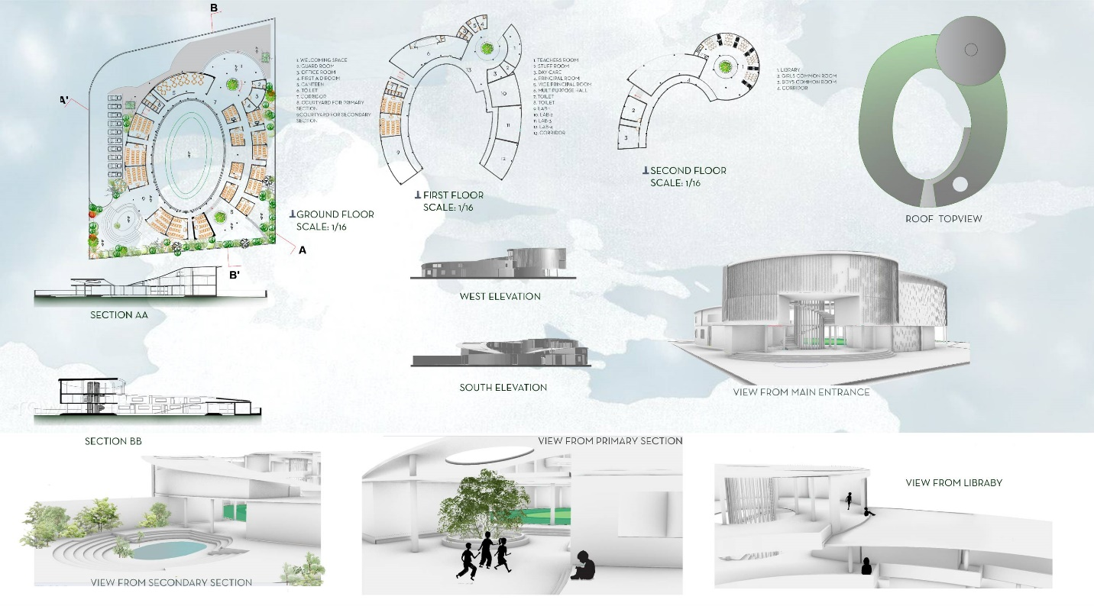

© Shanjida Afrin Eshika | UAP

**Programs:**

•Classroom: 20 nos for 25 students in each room

•Grade 01 to 10 (Each grade has two sections)

•Lab Room: 04 nos

•Library: 01 or 02 nos

•Multipurpose Hall

•Canteen: 01 nos with 20 seating facilities & small kitchen

•Boy’s Common Room: 01 nos

•Girl’s Common Room: 01 nos

•Principal's Room: 01 nos

•Vice Principal's Room: 01 nos

•Office Room: 01 nos

•Supportive Stuff’s Room: 01 nos for 10 persons

•Day Care: 01 nos

•Toilet: -Separate for Male & Female

-Separate for Students & Teachers

•Storeroom: 01 nos

•First Aid Room

•Guard Room with Accommodation: 01 nos

•Surface Parking Car: 10 nos

•20%-25% Circulation Space

•Dedicated Field

•25% MGC

**Project Brief:** Concept behind the design was "Envelope", where nature is enclosed.

I wanted to pick something from nature. Which can also be called biomimicry. I have matched the envelope with turtle. Because the turtle encloses itself in a shell, which is a kind of envelope. Therefore, the building form is inspired by a turtle cell. Here I have used a green roof with a slope, that way children can play on the roof with a source of outdoor learning and activities. I have also placed a library on the 3rd floor from where children can easily come on the roof.

Apart from this, there is a system of climbing from the ground to the roof. I have kept the classrooms of my school on the ground and kept separate courtyard for primary and secondary school children with landscaping where children can spend time on their own.